After making the video, I am now taking screenshots of my project operation.

The main page ->

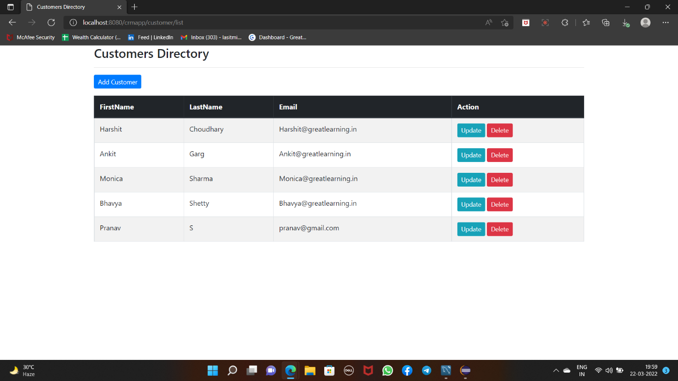

Now we press the Add Customer button on top. The following screen appears ->

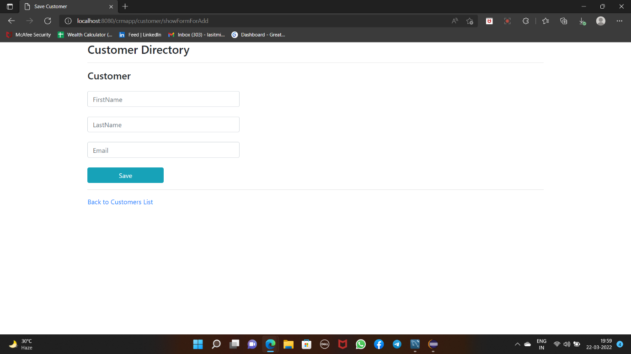

Here we need to fill the details. I am filling my details and will be performing CRUD on that.

After adding the details ->

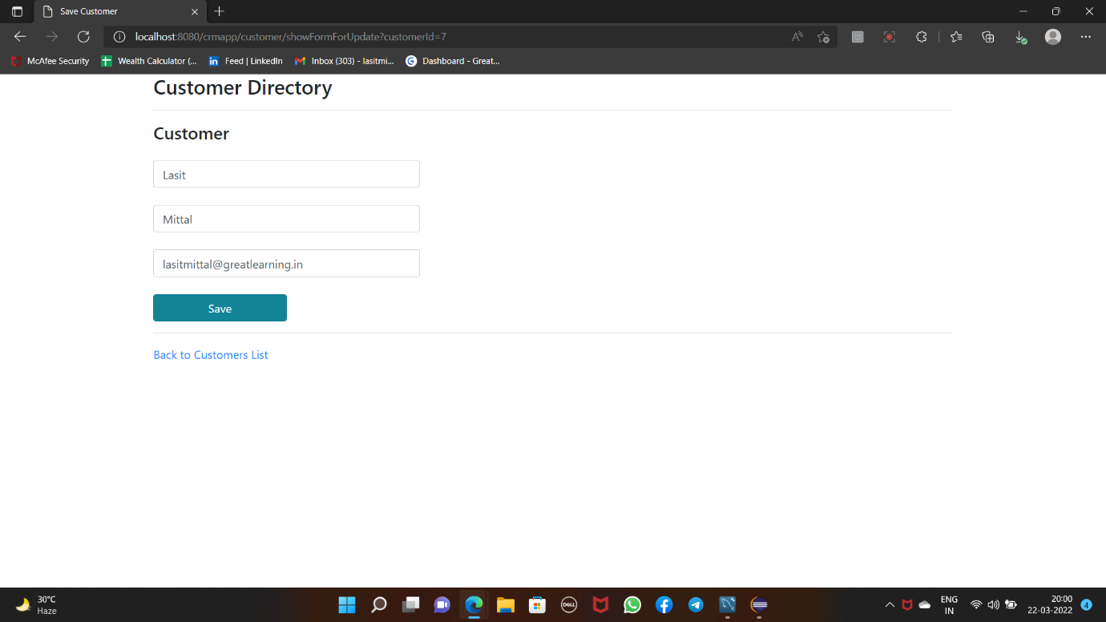

Now press Save. The main page again appears after saving the details ->

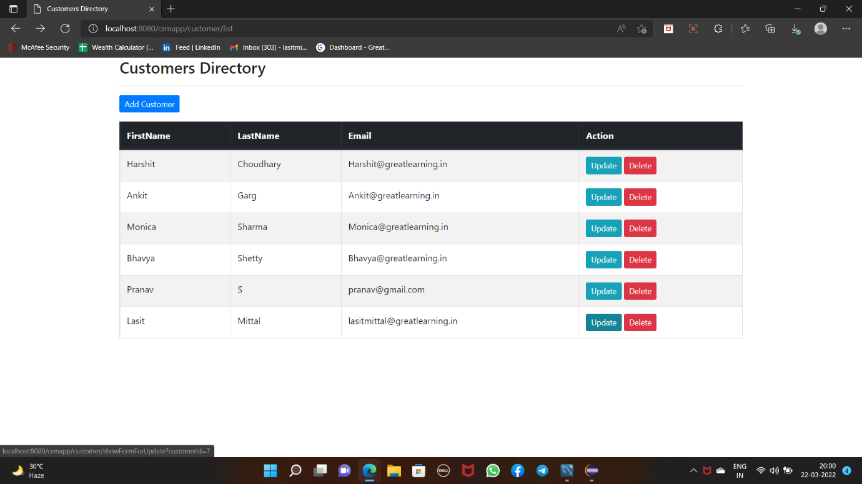

Next we perform the update operation

Press the update button. Make changes from @greatlearning.com to @ gmail.com.

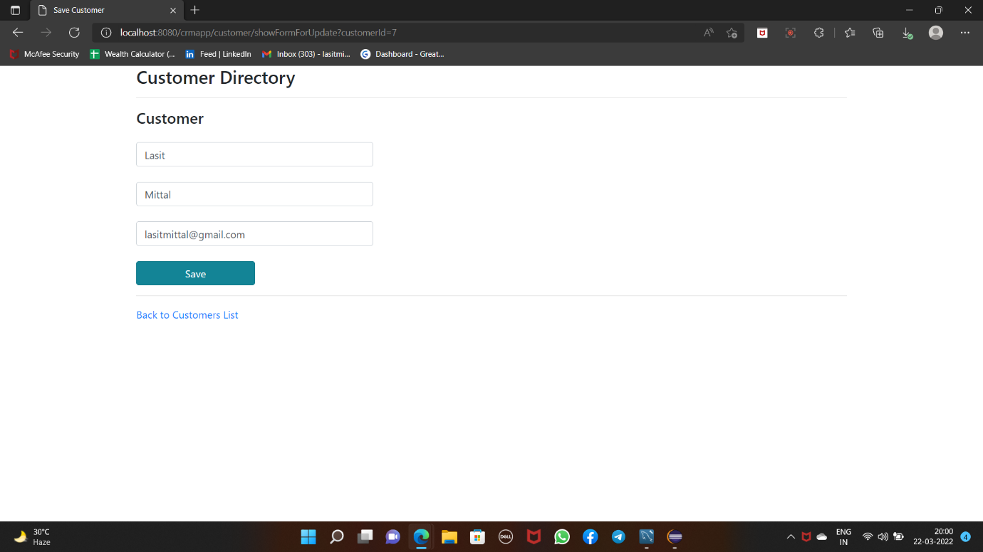

Now click on save. The main page reappears.

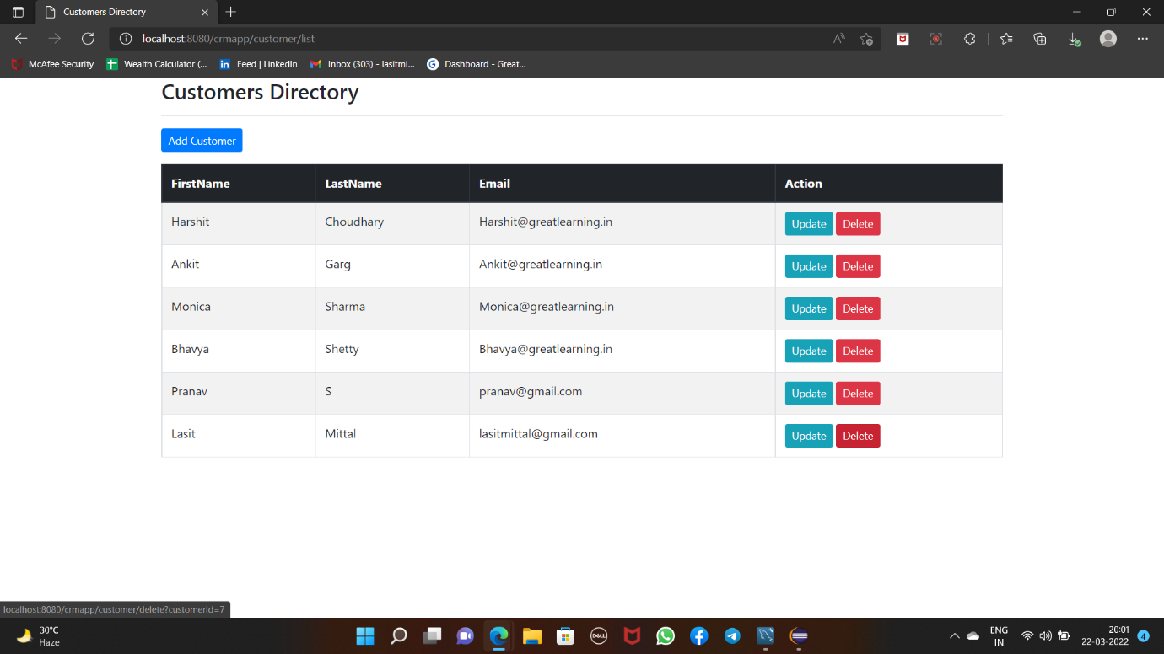

Now let us go inside the MySQL workbench and see there. On running the query we see the details are updated.

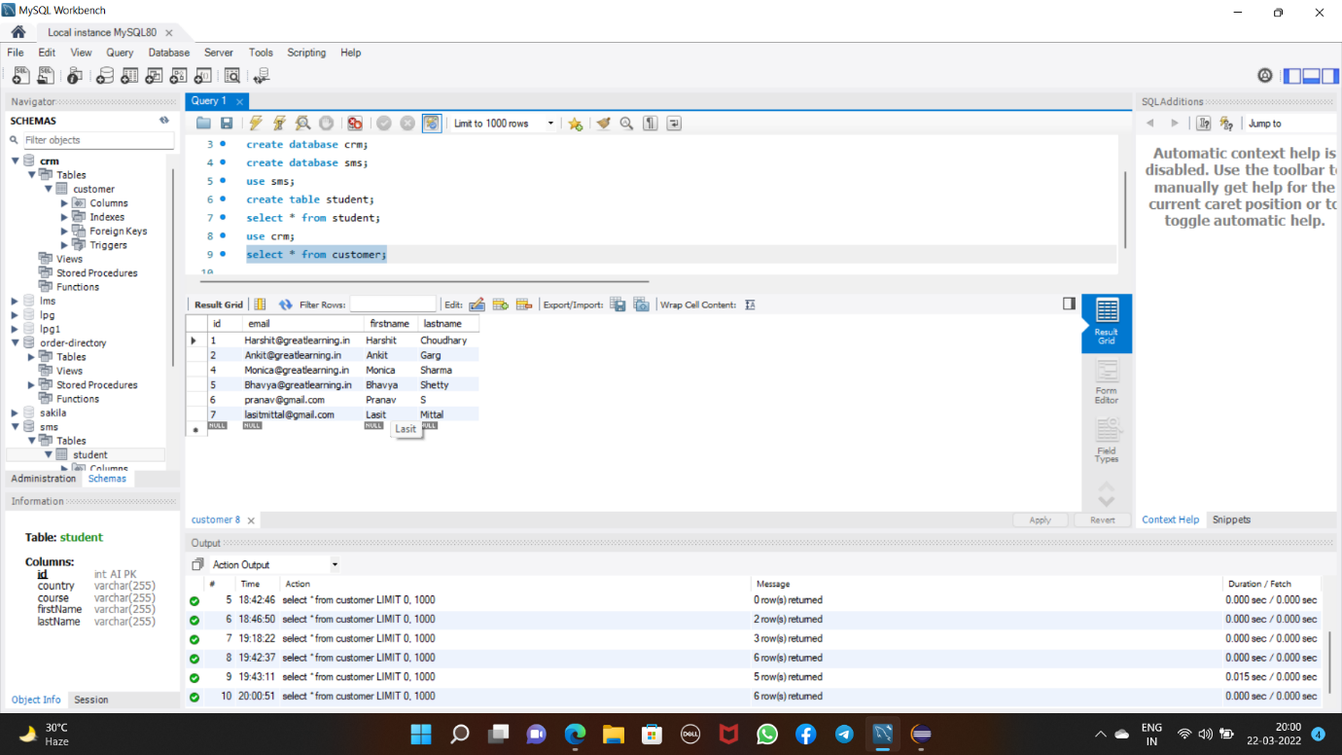

Now we perform the delete operation.

Press the delete button in main page ->



After this the popup opens confirming the operation ->

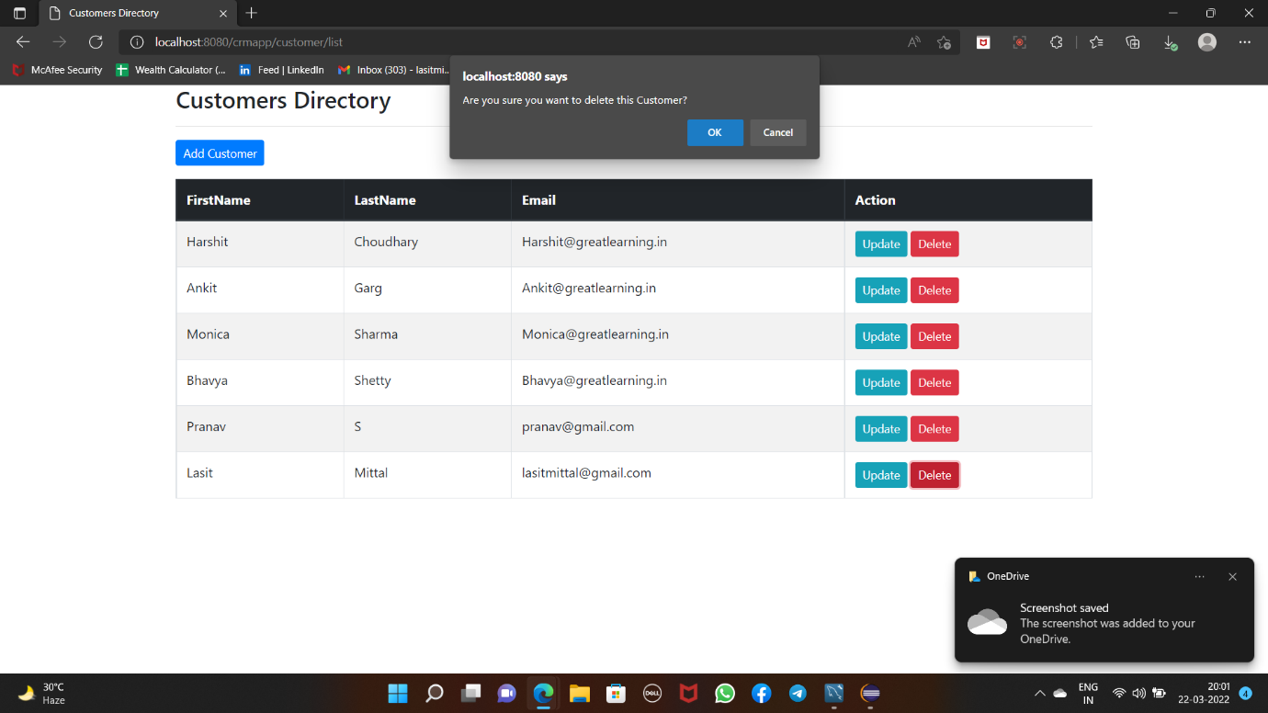

On clicking OK, the changes are made and main page reappears ->

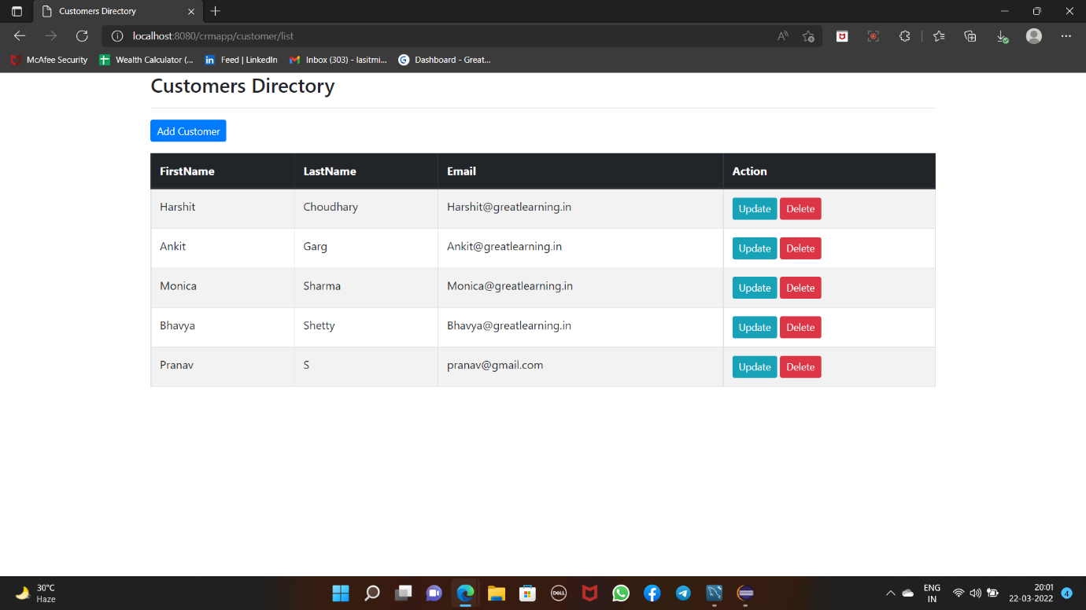

We can see that the entry of Lasit Mittal is now deleted.

Let us go back to MySQL and check. On running the query ->

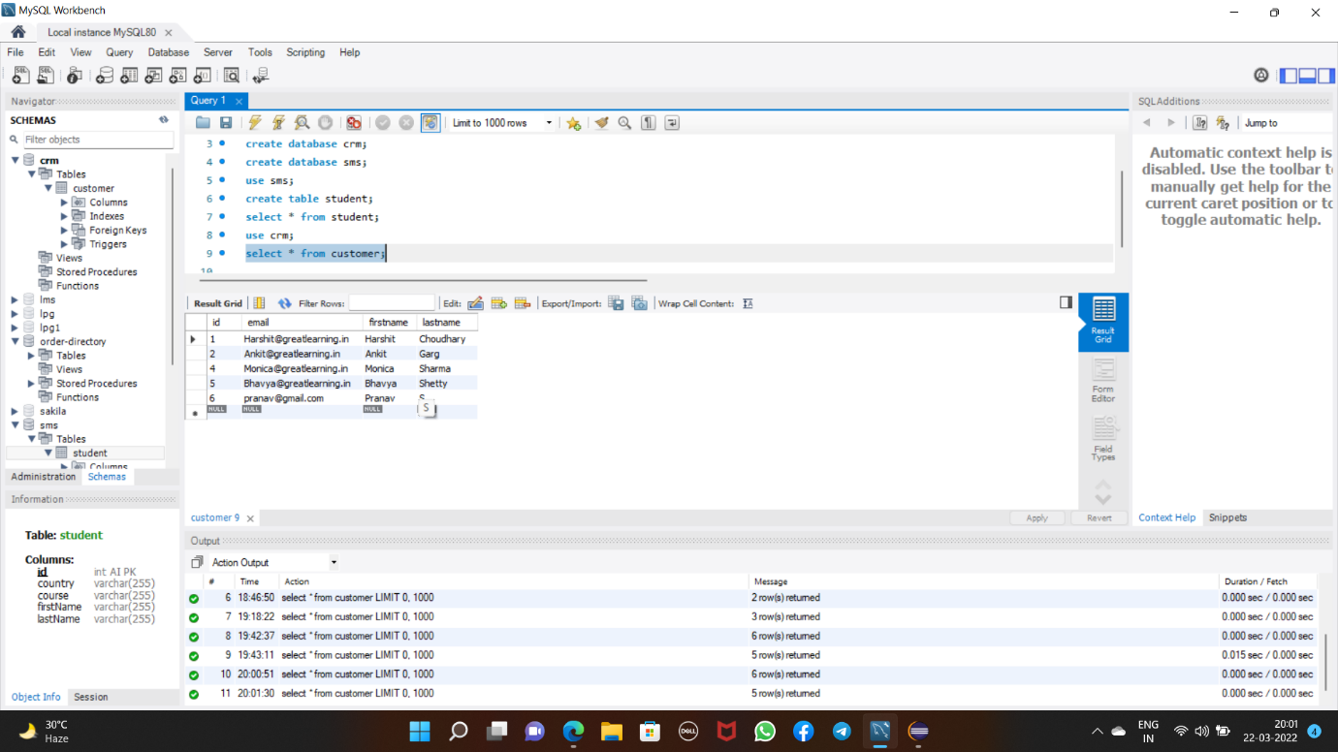

We see that the entry of Lasit Mittal with details is deleted from the database.

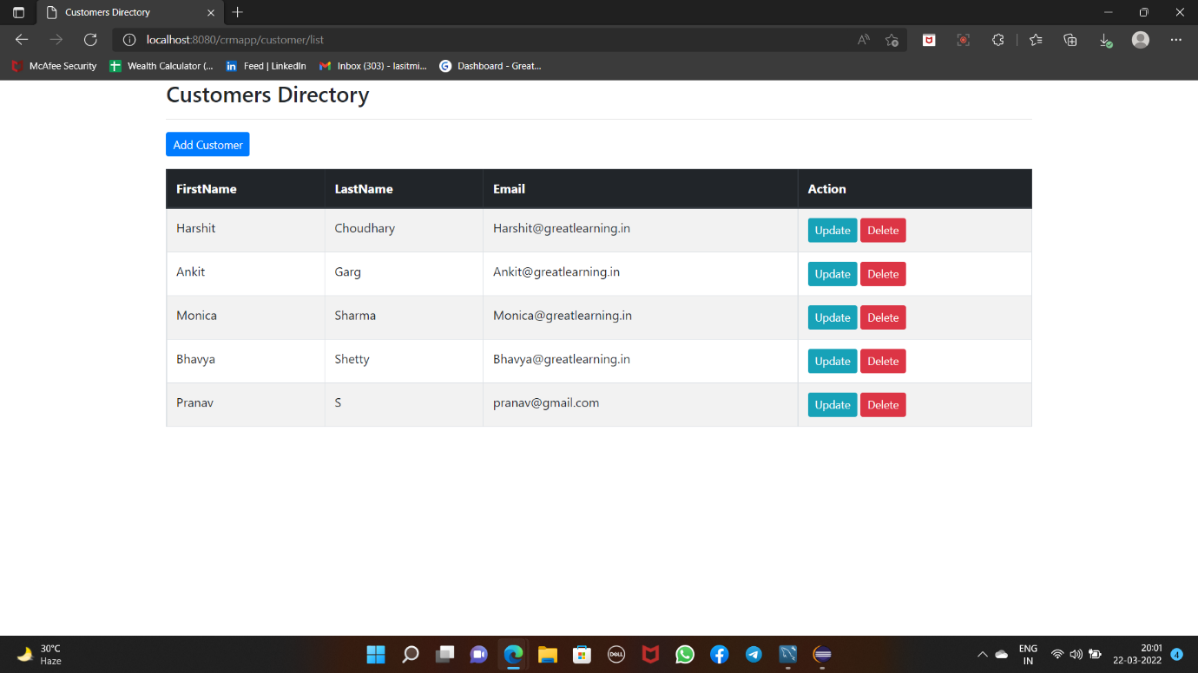

The End of CRUD operation.

Thanks